LINUX

------------------------------------------------------

An os is an interface bw user and hardware

OS manages the hardware

-------------------------------------------------------

ARCHITECTURE OF OS

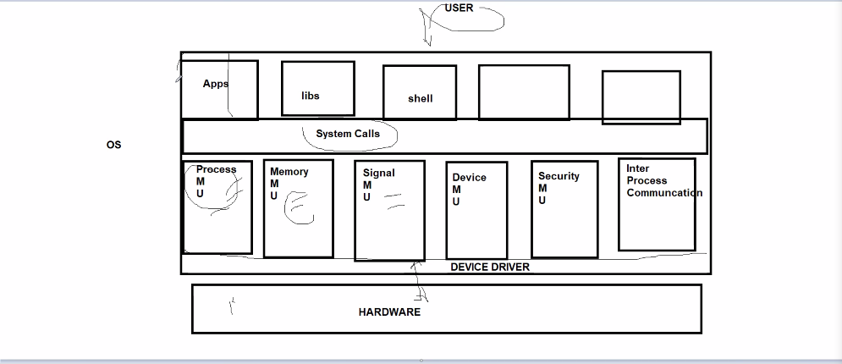

Lower most level of OS is device driver

It interacts directly with hardware .

device drivers has 3Cs :

Control

Configure

Coordinate

a) Device Driver

b)Process MU

c)Signal MU

d)Security MU

e)Inter Process Communication

f)System calls are fns and already a part of linux kernel

No library required for system call

eg:create/kill process ...we need a system call

--------------------------------------------------

SYSTEM CALLS

mkdir carl_zeiss

cat > file1

cat file1

cp file1 file2

(cp is done with the help of many system calls)

open f1 read only mode

open f2 create and write only mode

read f1

write f2

close f1

close f2

strace cp file1 file2:

Everything happens with the help of system calls

-------------------------------------------------------

PROCESS DESCRIPTORS IN LINUX

0-standard inp(stdin)

1-standard op(stdout)

2-standard error(stderr)

printf will internally call 1 stdout

Everything is in terms of system calls

---------------------------------------------------------

a) -> f) Linux Kernel

------------------------------------------------------------

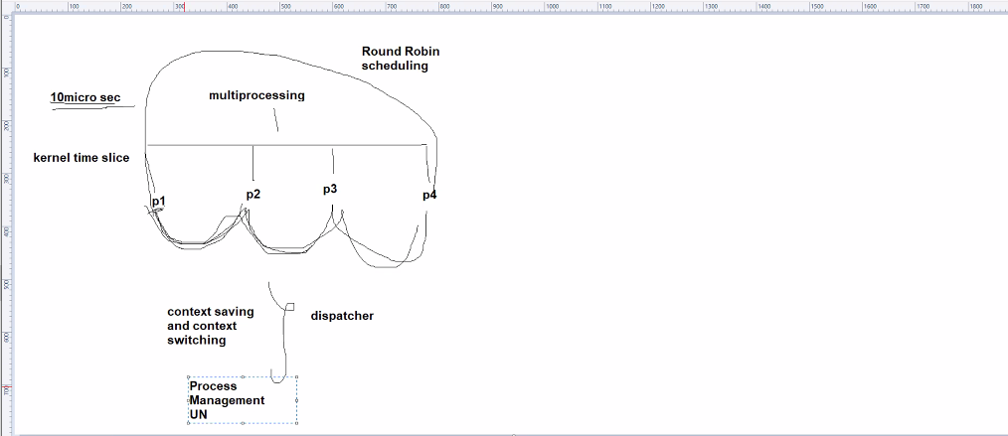

***1 processor can execute only 1 process at a single time

processor speed :in nanoseconds

On shifting from 1 process to another :(ROUND ROBIN)

save the current context address (CONTEXT SAVING & CONTEXT SWITCHING)

CONTEXT SAVING & CONTEXT SWITCHING DONE by Dispatcher

All of this is a part of Process MU

pid can never be 0..always +ve

When linux boots , the first process that starts is init /systemd process with pid=1

2 terminals =>2 bashes

1st terminal :ps

(ps will become child of bash1) 2nd terminal :ls

ppid of ps will be equal to pid of bash1

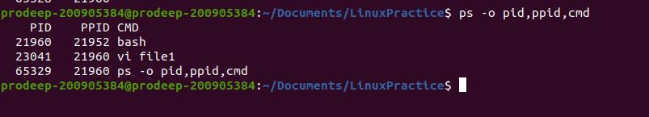

---------------------------------------------------------------------------------------

Note:ps will only show process in current terminal

**ps -e : shows all processes in system

pstree : shows process in the form of a tree

pstree -p:shows process with pid in ()

Note:gnome-terminal is the parent of all 2 bashes

Note:Process name can be same but pid always different

Note: vi file1.c (vi editor)

Note: sleep requires unistd.h

Note:ctrl c to terminate infinite loop

----------------------------------------------------------------

int x,y;

x=getpid();

y=getppid();

//2 system calls

Process States

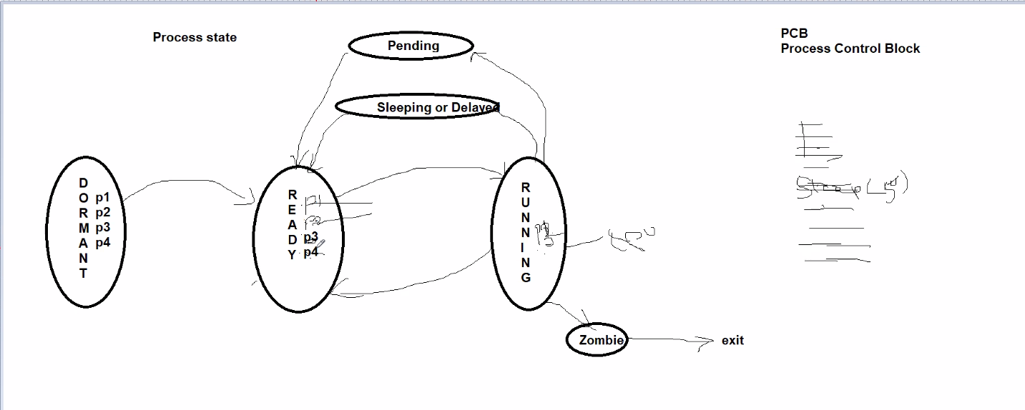

1)Dormant :Processes yet not created

2)Ready:./p1 ./p2 ./p3 ./p4

Process are in queue in Main Memory

3)Running:Dispatcher picks one of 4 processes

eg:p1 goes to running

executes for kernel time slice ..10ms

p1 goes back to ready state

Same for p2,p3,p4

4)Sleep:

Assume p3 is running

and inside p3 , there is sleep(50)

p3 goes to sleep state

only p1,p2,p4 in ready state

after 50s , p3 goes from sleep to ready state

5)Pending :

a)In semaphores

b)When parent has to wait for child to finish for indefinite time

Process here goes to pending state

Note: When time is known ->sleep state

When time is unknown/indefinite ->pending state

6)Zombie:

Ctrlc -> kill a process

--------------------------------------------------------------------------

PCB

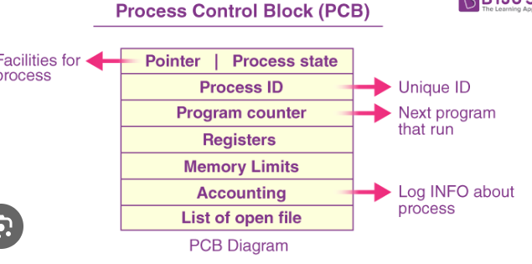

1 process has 1 process control block (structure)

PCB contains process related info

FORK SYSTEM CALL

Need for child process ?

Paytm server

Every time client needs service

The parent process creates a new child , and that child is specific to client1

And so on ….

fork()

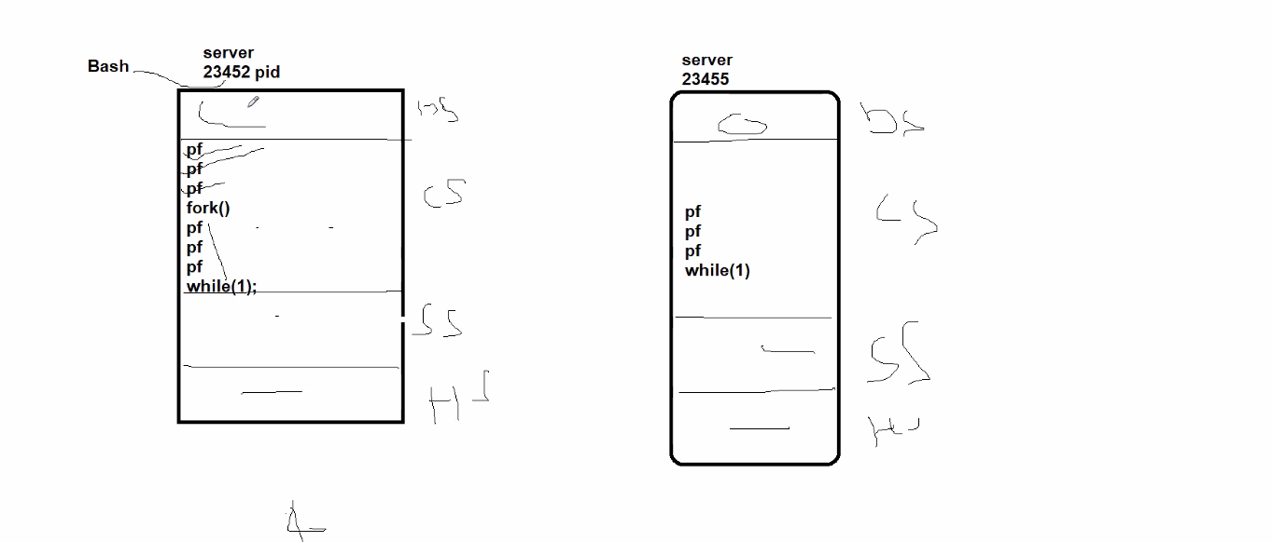

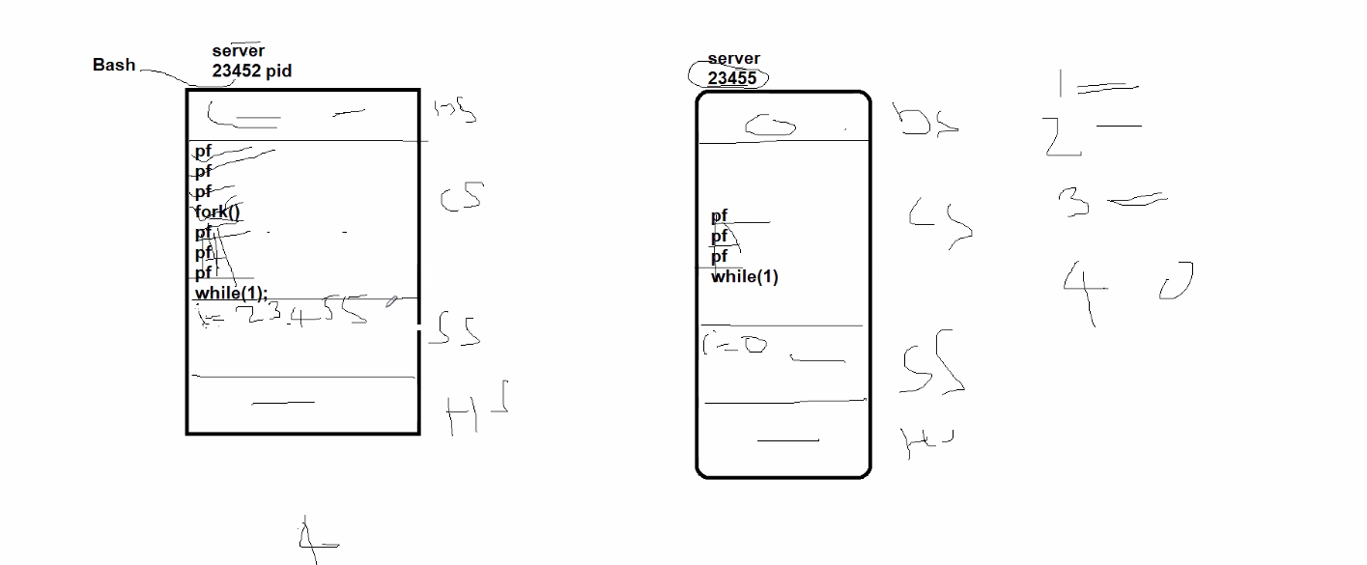

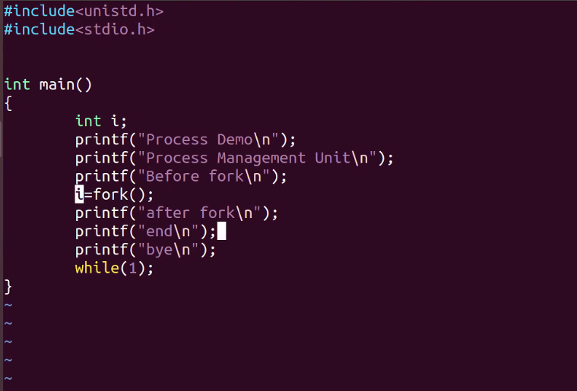

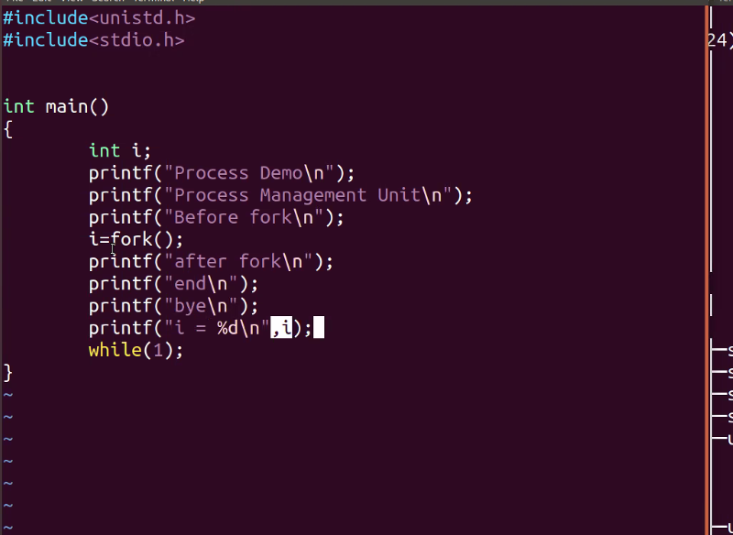

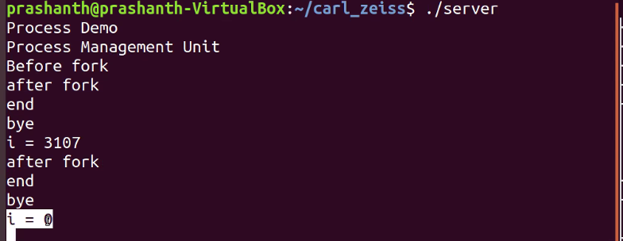



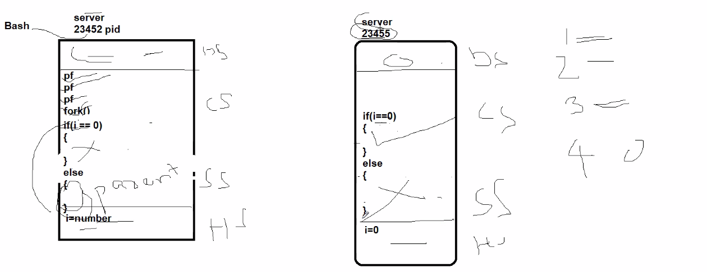

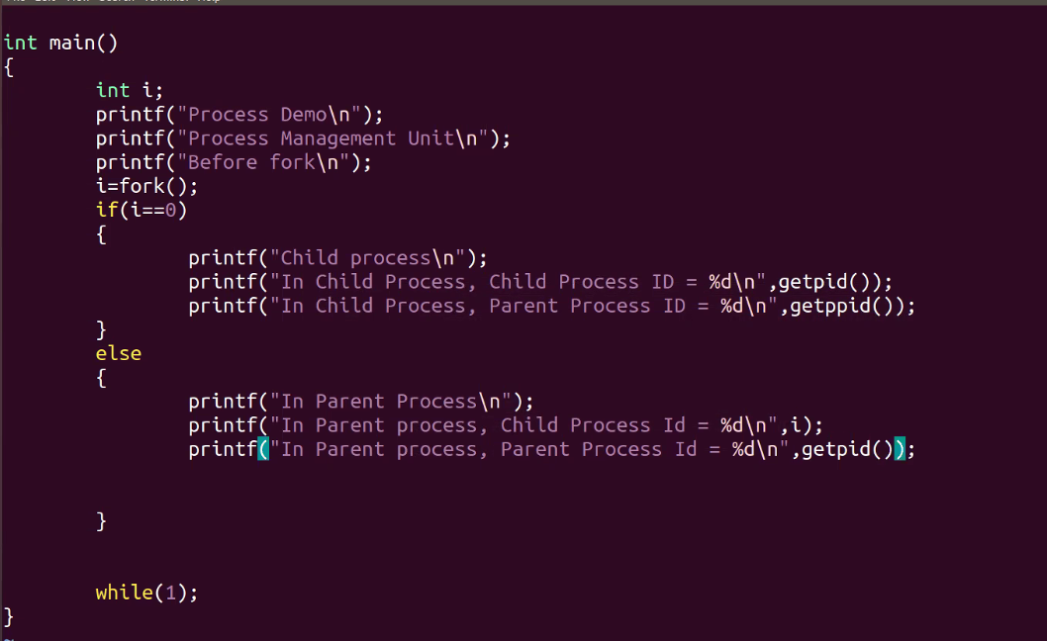

ORPHAN

SYNCHRONIZATION

ZOMBIE

1)Creates a new child process with same name but different pid

2)Copies all data /stack/heap segment of parent to the child

**But for code segment :

Only instructions after fork is copied from parent to child

3)Return a value (child pid )to the parent process

4)Return a value(0) to child process

Note:ps -ef //shows all processes along with pid and ppid

------------------------------------------------

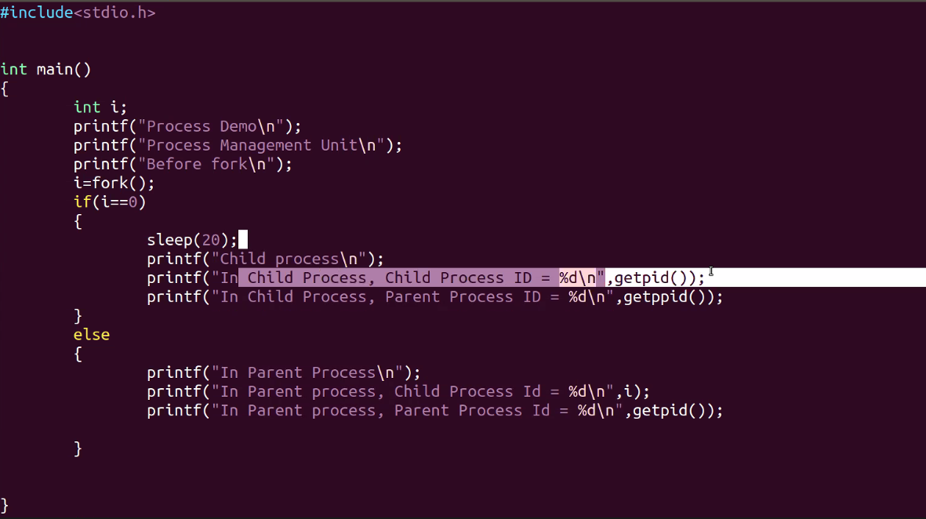

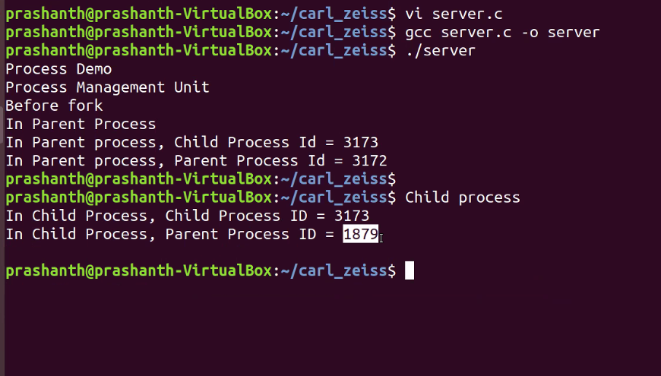

When any parent dies , all childs will become orphan

//when child wakes up , it sees its parent is dead

All orphan process adopted by init/systemd

Note: In ubuntu , orphan is adopted by local init/systemd

Other versions , the pid1 systemd

-------------------------------------------------------------

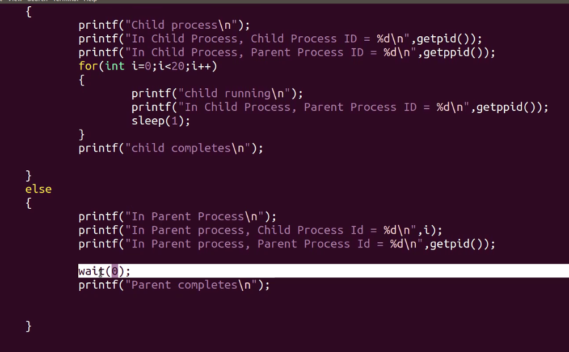

For sync and making sure parent doesnt finish exec before child

child->sleep(1);

parent->wait(0);

parent goes from running to pending state till child finishes jobs

CHILD WILL NEVER BECOME ORPHAN

wait:parent waits until child finishes its execution

Note:#include<sys/wait.h> required for wait()

-----------------------------------------------------------------------

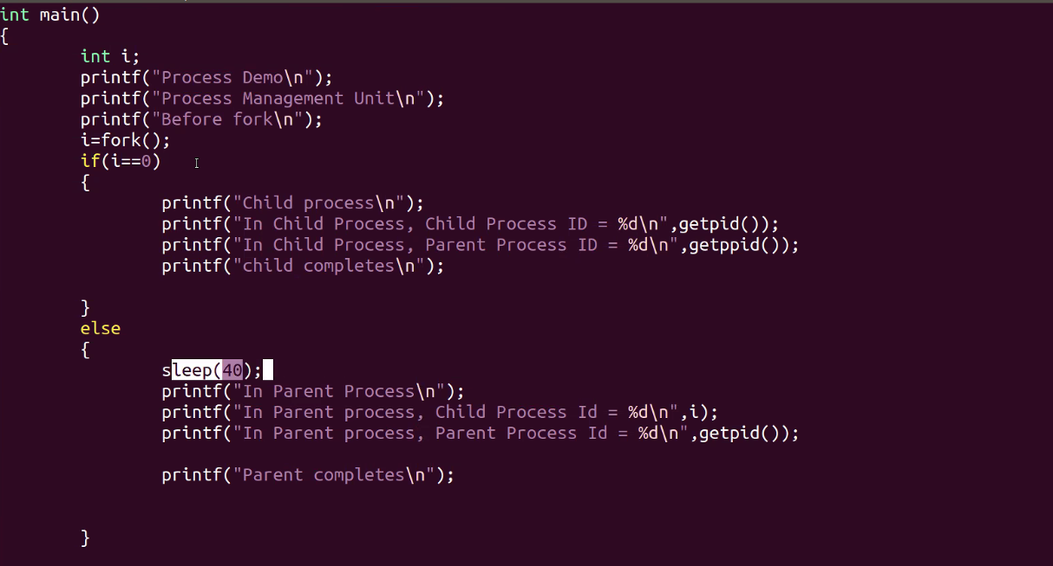

Child is dead but parent is sleeping

NO ritual for child

child is a zombie process

After 40s , status from zombie to exit status (parent frees the childs memory)

<defunct> =>zombie process

Note: No method to avoid zombie process

Like incase of orphan process

-------------------------------------------------------------

N consecutive fork

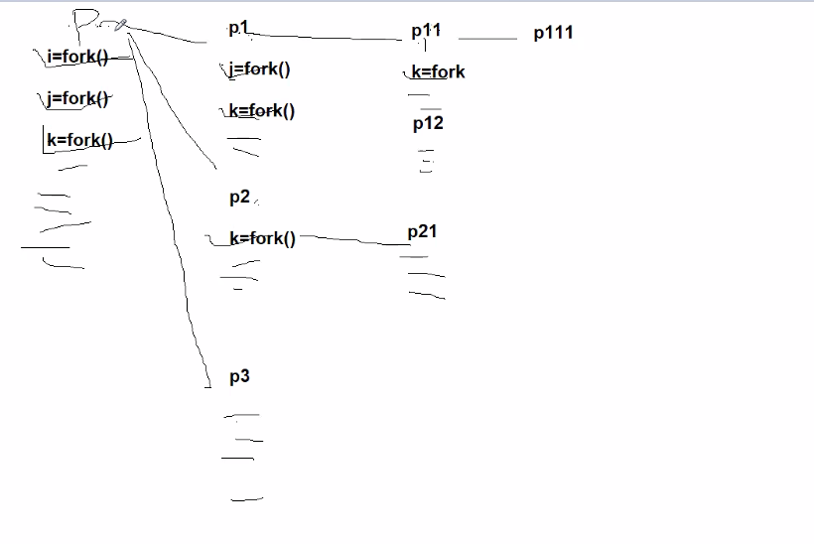

We will have 2^n -1 total new child processes

Including parent =>2^n processes

----------------------------------------------------------------

3 CHILD PROCESSES

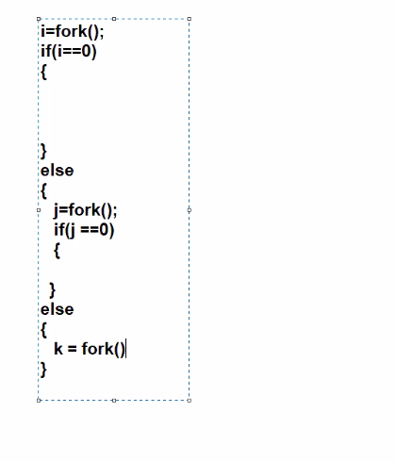

BOOTING PROCESS STEPS

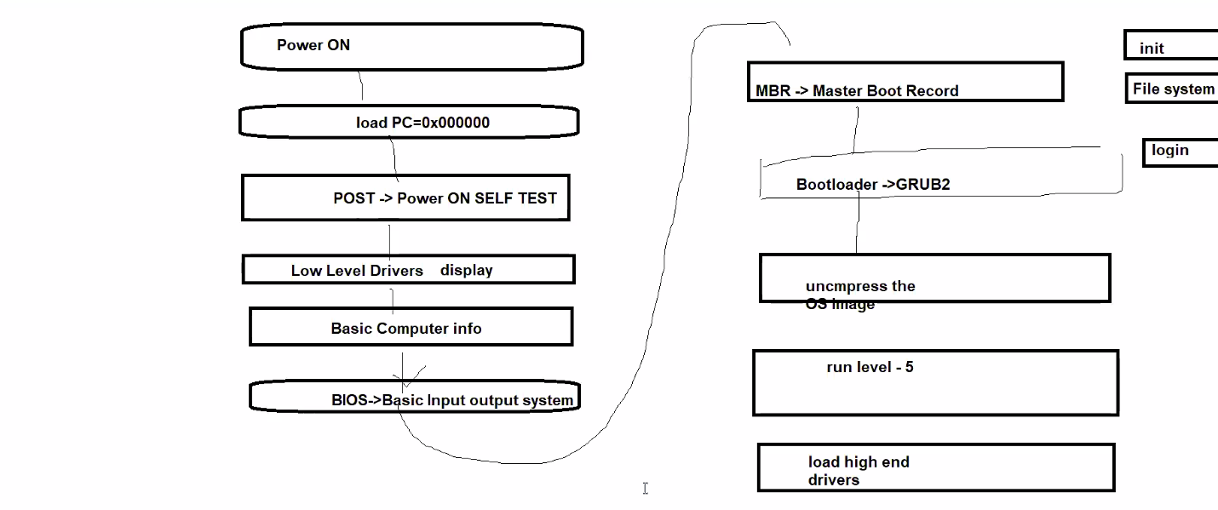

POWER ON SELF TEST=>

sends signal to all the devices

and checks if they are working

.That is why many lights glow

Low level drivers:

eg HP/DELL/ASUS

very dull and no Graphical enhancement

Basic comp info displayed

BIOS has basic drivers for keyboard

MBR holds the address of Windows OS/Linux Os(Bootloader)

GRUB :Takes into action if multiple os in single device

----------------------------------------------------------

IPC

RAM:a)Kernel Area b)User Area

MMU DIVIDES RAM into 2 parts

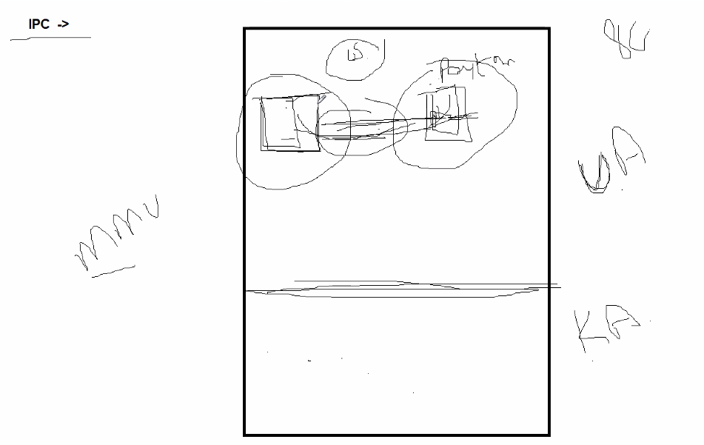

MMU protects user process

It wont allow 1 process to use memory space of another

process.

Eg:Paytm ...enter mobile no

2nd process overwrites mobile no

This shouldnt be allowed

**Each Process has separate memory area

**Through pipes, 2 process can exchange data with each other

eg:copy text from whatsapp to gmail(2 diff apps)

Kernel Area :system calls like fork , create file

User Area :.cpp file,c file , games

-------------------------------------------------------

Types of IPC

PIPES

FIFO

(above 2 primitive)

Message Queue

Shared Memory

Semaphores

(above 2 system V)

Socket

(BERKLEY SW DEVELOPMENT)

-------------------------------------------------

1)Pipe ->Only Related processes

(only bw parent & child )

Half duplex

(Only 1 operation at a time )

Unidirectional

For Full duplex:2 pipes

2 Descriptors /Ends

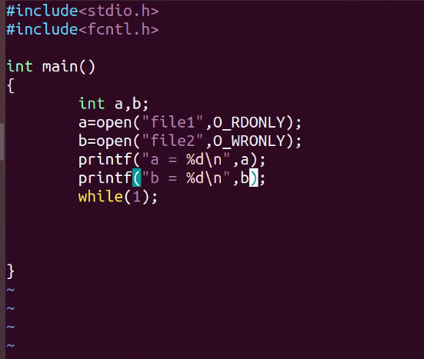

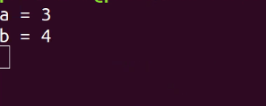

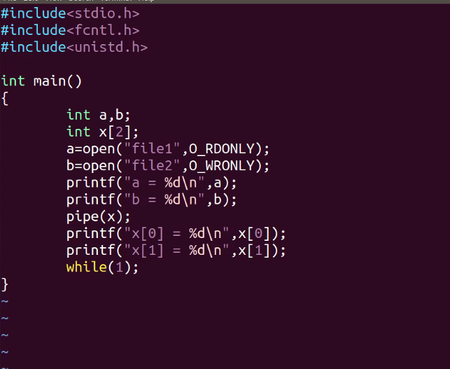

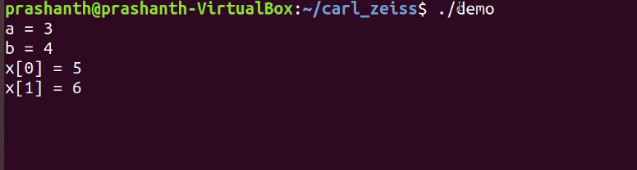

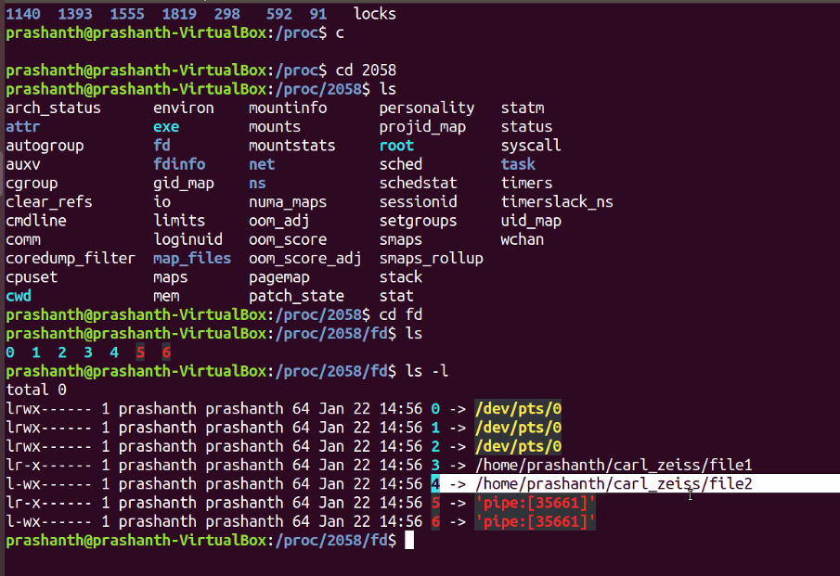

FILE DESCRIPTORS

int a,b;

a=open("File1",O_RDONLY);

b=open("File2",O_WRONLY);

To check file descriptors

cd /proc

cd 1994

cd fd

ls

PIPE DESCRIPTORS

It has 2 ends

so pipe() takes an array of 2 size

int x[2];

pipe(x);

x[0]->read end

x[1]->write end

dis of pipes:cannot communicate bw 2 unrelated processes

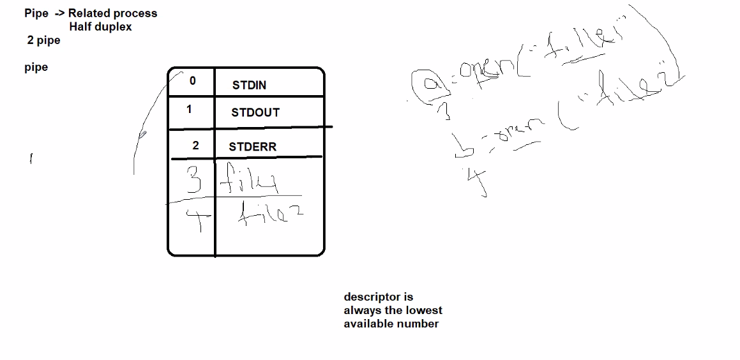

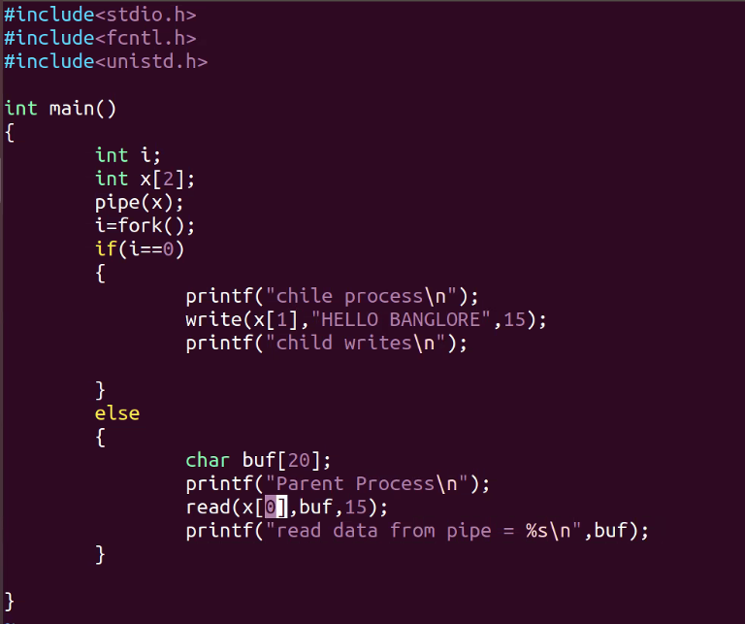

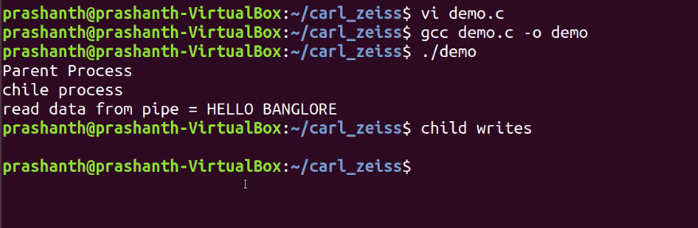

2 way through pipes

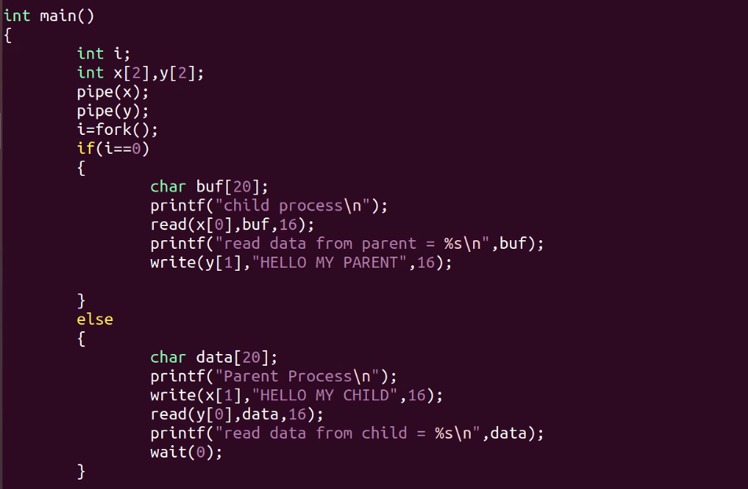

-------------------------------------------------------

FIFO

FIFO pipes->named pipes

Also half duplex

--------------------------------------------------

1st terminal :mkfifo f1

cat f1 //read

2nd terminal:

cat >f1 //write

Happens only when both parties are ready to read and write

---------------------------------------------------------

2 Programs for FIFO

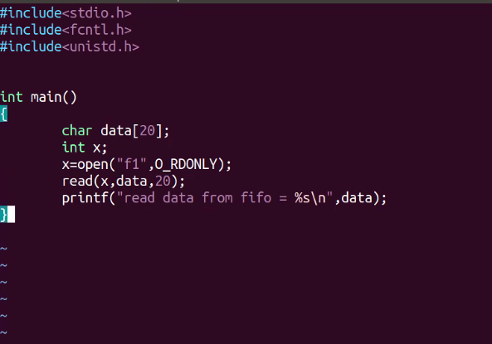

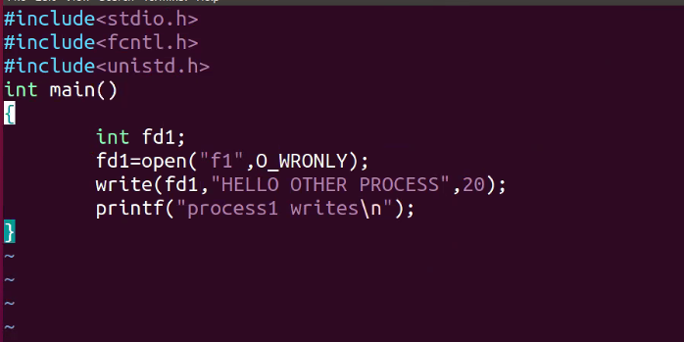

2 WAY COMMUNIATION